**SeisNet: A simple CNN for rapidly classifying historic records from the WWSSN**

T.P. Nagle-McNaughton1,2*, A.T. Ringler2, R.E. Anthony2, D.C. Wilson2, J.T. Wilgus1,2

*Corresponding author

1Department of Earth and Planetary Science, The University of New Mexico

2United States Geological Survey-Albuquerque Seismic Laboratory

# Abstract

Insert abstract here

# 1. Introduction

## 1.X The WWSSN archive

Insert a paragraph outlining the WWSSN

Over the 16 years between 1962 and 1978, the WWSSN generated approximately 3.7 million single-day record film chips [1]. Over two different efforts, film chips were digitized via high-resolution scanning at ~3200dpi and the resulting 8-bit images span ~8,000x3,500 pixels (28 megapixels) [1]. At the time of writing, the USGS has 189,180 scanned film chips, comprising some 6TB of data. Of these, ~27,000 are available online: <ds.iris.edu/spud/filmchip> [1]. The currently digitized chips comprise only 5.1% of the entire WWSSN archive, but at a cost of ~$4 per scan [1], significant funding will be required to digitize the remaining 95% unscanned film chips.

That said, the archive is already too large to manually explore at present. Even with the help of low-cost intern work, systematically going through this archive to identify interesting film chips would be daunting and labor-intensive. As such, we identified a need to develop an automated method for rapidly parsing film chips and identifying chips with interesting events. To that end, in this study we develop and present a novel approach to classifying the WWSSN records using a simple CNN we call “SeisNet”.

Insert paragraph here about the usefulness

## 1.X CNNs and image classification

Convolutional neural networks (CNNs) are regularized networks that are inspired by biological processes, and have found widespread use and efficacy in image classification and computer vision problems [2–4]. Research has found that a simple CNN can have the ability to perform many different complex tasks depending on its training data, including object recognition and classification, attribute detection, and object/image retrieval [5]. CNNs have been highly effective in problems such as handwriting recognition [6,7], cancer detection in medical images [8–12], and classifying features in remotely sensed data [13–15]. As CNNs have grown in popularity, their accessibility has also increased. There are many excellent libraries and resources for developing custom CNNs [16–24], and more complex off-the-shelf models have become extremely prevalent for a range of applications as transfer learning has improved [25–28].

# 2. Methods and data

## 2.X Data pipeline

We developed a simple nine-step data processing methodology for generating labels for WWSSN film chips (Figure 1). Once a WWSSN film chip has been loaded into memory, the edges of the chip are masked out to eliminate any irrelevant scan errors or annotations that are not seismic data (Figure 2). The image is converted from 8-bit greyscale to 1-bit binary. A random 200x200 ‘tile’ is cropped out from the scan, and its brightness level is checked. Some of the film chips have dark smudges which obscure the seismic data (Figure 3), and the brightness check is able to eliminate tiles which contain those smudges. The pipeline will only accept tiles that are between 50% and 95% white. If the tile fails this check, the tile is. If the tile does pass the brightness check, it is classified by SeisNet into one of three classes: ‘no events’, ‘minor events’, and ‘major events’. This crop-check-classify process is repeated until a desired number of sample tiles have been generated. Once the minimum number of samples has been reached, the tiles and their classifications are evaluated in ensemble to generate one of four labels for the entire film chip: ‘no interest’, ‘little interest’, ‘some interest’, and ‘high interest’.

Figure 1. The overall processing pipeline for classifying film chips. 1) A film chip is downloaded and loaded into the processing directory. 2) The edges of the tiles that contain metadata and scan artifacts are masked/cropped out (See Figure 2 below). 3) The film chip is converted from 8-bit greyscale to binary. 4) A random 200x200 tile is cropped out of the masked area. 5) The overall brightness of the tile is evaluated, if it is too dark, it is ignored and a new crop is taken, if the tile is bright enough, it is evaluated. 6) The tile is classified by SeisNet. 7) The results are saved to a database. 8) The cropping and classification process is repeated until the user-defined minimum sample threshold is achieved. 9) An overall label for the film chip is derived from the database of tile classifications.

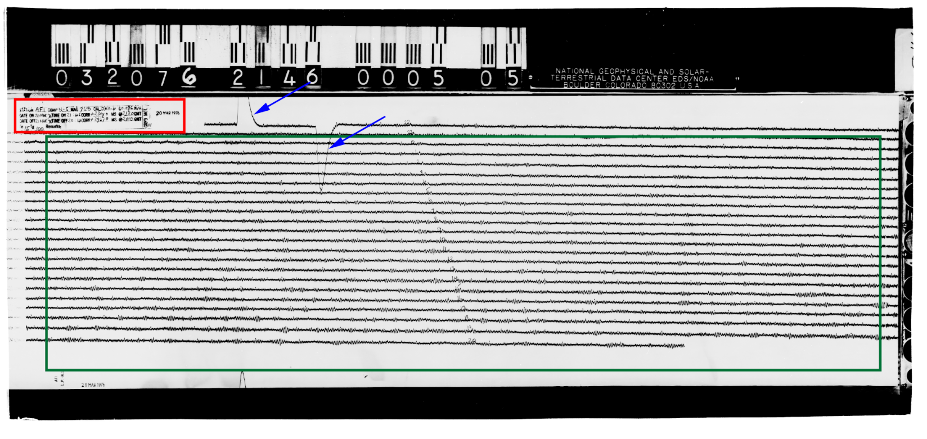

Figure 2. An annotated film chip. The red rectangle marks metadata stamped on the film chip, the blue arrows mark the calibration pulse, and the green rectangle annotates the masked area containing useful information. Note that the masked area excludes the black film chip header and footer, the metadata, and artifacts on the right of the image. This prevents unusual or erroneous data from being included in sampling. In the center of the record the station operator manually labeled each hour.

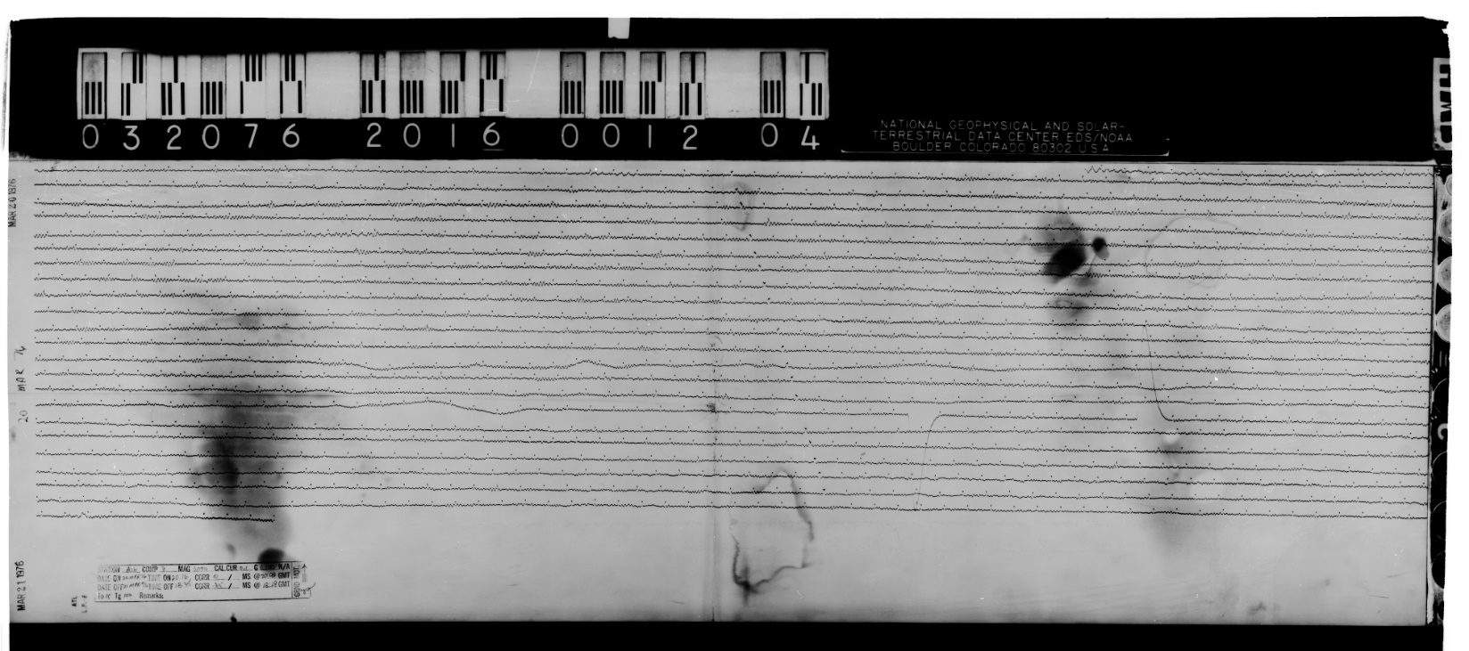Figure 3. An example of a film chip with dark smudging inside the masked area. Checking the overall brightness of each tile allows these areas to be skipped during sampling.

## 2.X Model architecture

SeisNet is a relatively simple sequential CNN developed using the Python package Keras [17]. SeisNet is composed of three convolutional blocks, one dense block, a dropout layer, and an output layer (Table 1). In total the model has 598,124 parameters, of which all but 384 were trainable. In total, the full model and all of its parameters are only 7.5MB in size.

Table 1. SeisNet architecture. Line colors indicate the different blocks.

|  |  |  |  |
| --- | --- | --- | --- |
| **Block** | **Layer type** | **Output shape** | **Number of parameters** |
| Convolution 1 | Conv2D | (None, 200, 200, 32) | 832 |
| MaxPooling2 | (None, 100, 100, 32) | 0 |
| Convolution 2 | Conv2D | (None, 50, 50, 64) | 51,264 |
| MaxPooling2 | (None, 25, 25, 64) | 0 |
| Batch normalization | (None, 25, 25, 64) | 256 |
| Convolution 3 | Conv2D | (None, 13, 13, 128) | 73,856 |
| MaxPooling2 | (None, 6, 6, 128) | 0 |
| Batch normalization | (None, 6, 6, 128) | 512 |
| ANN | Flatten | (None, 4608) | 0 |
| Dense | (None, 100) | 450,900 |
| Dense | (None, 100) | 10,100 |
| Dropout | Dropout | (None, 100) | 0 |
| Output | Dense | (None, 4) | 404 |

## 2.X Training dataset generation

SeisNet was trained on 18,154 200x200 tiles randomly sampled from 460 scanned film chips. A list of the source film chips used is available at: <https://github.com/TimNagle-McNaughton/USGS/scan_classification>. Information the film chip naming conventions can be found at <https://github.com/aringler-usgs/Film_chip_code/blob/master/wwssnlist.csv> for location codes and <https://ds.iris.edu/ds/nodes/dmc/data/formats/seed-channel-naming/> for channel names.

The training tiles were manually classified by the first author into four classes: 1) no events, 2) minor or micro events, 3) major events, and 4) scan errors and calibration pulses. The class breakdown of the training set is given in Table 2. The dataset was randomly shuffled, and then split into a training set and a validation set: 80% for training and 20% for validation during training. The training tiles were augmented by random vertical and horizontal flips. This augmentation helps the model generalize and prevents overfitting [29–31].

Table 2. Training dataset class counts. Note the low count of error tiles.

|  |  |
| --- | --- |
| **Class name** | **Occurrences in training data** |
| No events | 6,539 |
| Minor events | 8,393 |
| Major events | 3,049 |
| Errors | 173 |

## 2.X Model training

During training, the model used the Adam optimizer and a learning rate of 1x10-5 [32]. As the model trained, the model was saved every time it improved its performance on the validation dataset as measured by accuracy. The dropout rate was set to 40% to prevent the model from overfitting. Dropout resets some fraction of the nodes by temporarily making their weights equal to 0 [33,34]. Some fraction of the layer nodes are thus randomly ignored or ‘dropped out’ and the updates to the weights during training are based on a different ‘view’ of the layer. This process adds noise to the training process, forcing nodes to probabilistically take on more or less ‘responsibility’ for the inputs as they are either ignored or relied upon, which greatly helps prevent overfitting [33,34]. The dropout rate of 40% in SeisNet meant that every training iteration, 40% of the ANN output nodes were reset.

The model was trained on high-end consumer-grade hardware: a 12-core 3.8GHz AMD Ryzen 9 3900X CPU, with 64GB of DDR4 3200MHz RAM, and a NVIDIA GTX 1080 GPU. The data were stored on 2TB Samsung 860 EVO SSD. The small size of SeisNet did not warrant parallelization via the GPU, so all training, testing, and applications were done via the CPU.

## 2.X Determining sample frequency

The data pipeline was designed to randomly sample unique tiles from each film chip until a minimum number of samples had been generated. Sampling a fraction of the chip’s area is a more efficient than simply classifying the entire area, and given the number of film chips in the USGS archive, optimizing this process was crucial. This minimum value was selected by evaluating the variability of each sample size. To measure this variability, different sample sizes were tested repeatedly across an evaluation set of 50 film chips. The masked area of each film chip is composed of approximately 250 tiles, so sample sizes of 10, 25, 50, 100, and 200 tiles were tested. With a confidence threshold of 85% an average score across five runs for each chip was calculated using values of 0 for ‘no events’, 1 for ‘minor events’, and 2 for ‘major events’. The mean scores for the tiles in each run were then compared to determine the optimal sampling frequency.

## 2.X Label generation

Because many sample tiles are taken from each film chip, and the samples are evaluated in ensemble to generate an overall label, an accuracy of 92% for each chip was sufficient for our application. The following logic was then applied to each chip’s database for each film chip to determine an overall label:

* If the maximum tile classification score is 0: label = ‘no interest’
* If the maximum tile classification score is 1: label = ‘little interest’
* If the maximum tile classification score is 2 & the mode of tile classifications score is 2: label = ‘high interest’
* If the maximum tile classification score is 2 & the average tile classification score is greater than 1.5: label = ‘interest’
* If the maximum tile classification score is 2 & the average tile classification score is greater than 1.5: label = ‘high interest’

These labels are intended to assign some gradation of interest to the film chips. Here again the differentiations between adjacent classes (i.e. between no and little interest, or between high and some interest) are likely to be fuzzy and imperfect. However, these labels are not the end-all-be-all of this project. Even with some intrinsic fuzziness, these labels should enable better filtering of the chips, more efficient exploration of the archive, and ultimately the production of further research. To measure the model’s efficacy in generating these labels, manual and automated classifications were compared. The 50 evaluation tiles were independently reviewed and classified by each author. The average classification (the consensus) was then compared to those generated by the model.

## 2.X Applying the model

# 3. Results

## 3.X Model training

SeisNet was trained for 50 epochs, and the iteration with the best performance on the validation dataset was saved. Each epoch of training took ~170s, or about 85 tiles/second on the CPU. In this case, the model’s performance peaked after 35 epochs, or ~100 minutes. The final model had values of 0.3432 for loss, 0.8658 for accuracy, 0.4726 for validation loss, and 0.8221 for validation accuracy. The small difference between the training set accuracy and the validation accuracy (only 4.37% worse on the validation set) is a strong indication that the model was not overfit and was well-generalized. A large difference between the two values would suggest that the model had overfit. For example, if the training score were 10% greater than the validation score, additional work would be required to prevent overfitting.

## 3.X Single-tile classifications and confidence thresholds

Testing the model on the validation dataset showed that the fully trained model generates classifications at a rate of ~450 tiles/second in a single instance on the CPU. This performance could likely be improved through parallelization on the GPU, but for our purposes this speed was sufficient.

The training metrics outlined above did not account for the model’s confidence in its classification, and performance was improved by implementing a confidence threshold which enable a better understanding of the model’s capabilities. For example, the model may make an incorrect classification with only 60% confidence in that classification, which would be much less concerning than the model making the same classification with 98% confidence. The lower confidence threshold would likely indicate that the tile was ambiguous, perhaps somewhere between no events and minor events. Having low confidence in that case would actually be good even if the classification is incorrect. Conversely, if the model were highly confident in an incorrect classification, that might indicate a much more serious problem with how the model is parsing, analyzing and classifying the images.

The performance of the model is thus best evaluated when the low-confidence classifications are ignored, since they likely represent ‘coin-flip’ scenarios where the tile is ambiguous and could have been subjectively misclassified in the training dataset. By setting a high minimum confidence threshold, we can assess how well the model actually understands the problem in clear-cut instances. A confidence threshold of 85% percent was thus implemented. When the validation dataset was evaluated, the model exceeded that 85% confidence for two-thirds of the validation tiles, meaning that the model was highly confident in 66% of its classifications. A comparison of standard metrics with and without a confidence threshold is presented in

Table 3. With the 85% confidence threshold, the model’s overall accuracy increased from 82% to 92%, suggesting that the majority of the model’s incorrect classifications were among low-confidence tiles (Figure 4).

|  |  |
| --- | --- |
| 1. (32%, 19%, 42%, 7%) | 1. (1%, 42%, 57%, 0%) |
| 1. (0.5%, 49.7%, 49.3%, 0.5%) | 1. (2%, 46%, 51%, 1%) |

Figure 4. Examples of low-confidence tiles with confidences for each class: (none, minor, major, error). Both A) and B) have relatively low-amplitude waveforms, but the samples contain large amplitude variability, which is characteristic of a more significant event. These tiles were misclassified as containing major events when they contain minor events. C) and D) both appear to have longer period microseisms, but D) contains a large irregularity in the third line. C) was correctly classified as containing minor events, and D) was correctly classified as containing the beginning of a major event.

Table 3. Model performance with and without a confidence threshold.

|  |  |  |  |  |  |  |  |  |
| --- | --- | --- | --- | --- | --- | --- | --- | --- |
|  | No minimum confidence | | | | Minimum confidence = 85% | | | |
| Precision | Recall | F1 | Support | Precision | Recall | F1 | Support |
| No events | 0.84 | 0.88 | 0.86 | 1,309 | 0.93 | 0.96 | 0.94 | 1,013 |
| Minor events | 0.85 | 0.82 | 0.83 | 1,666 | 0.92 | 0.93 | 0.92 | 1,030 |
| Major events | 0.72 | 0.76 | 0.74 | 618 | 0.87 | 0.82 | 0.84 | 321 |
| Errors | 1.00 | 0.00 | 0.00 | 38 | 1.00 | 0.00 | 0.00 | 16 |
|  |  | | | |  | | | |
| Accuracy | 0.82 | | | 3,631 | 0.92 | | | 2,380 |
| Macro mean | 0.85 | 0.61 | 0.61 | 0.93 | 0.68 | 0.68 |
| Weighted mean | 0.82 | 0.82 | 0.82 | 0.92 | 0.92 | 0.91 |

A confusion matrix for the validation dataset was generated (Figure 5). This diagram illustrates misclassifications across the four classes used in this model. There is some confusion between no events and minor events (~6%), and between minor events and major events (17%), but notably there is almost no overlap between no events and major events (<1%). Given that these classifications are subjectively derived from a continuous spectrum of waveform patterns, the overlap between adjacent classes is unsurprising, but it is promising that there is essentially no overlap between the end-members. The model was unable to classify any error tiles and confused them with the other classes. Given their extreme rarity in the training and test datasets, these misclassifications of error tiles are acceptable. The network’s inability to classify these features likely is a combination of class imbalance in the training data, and the fact that tiles with errors still contain other information that the network can identify (Figure 6).

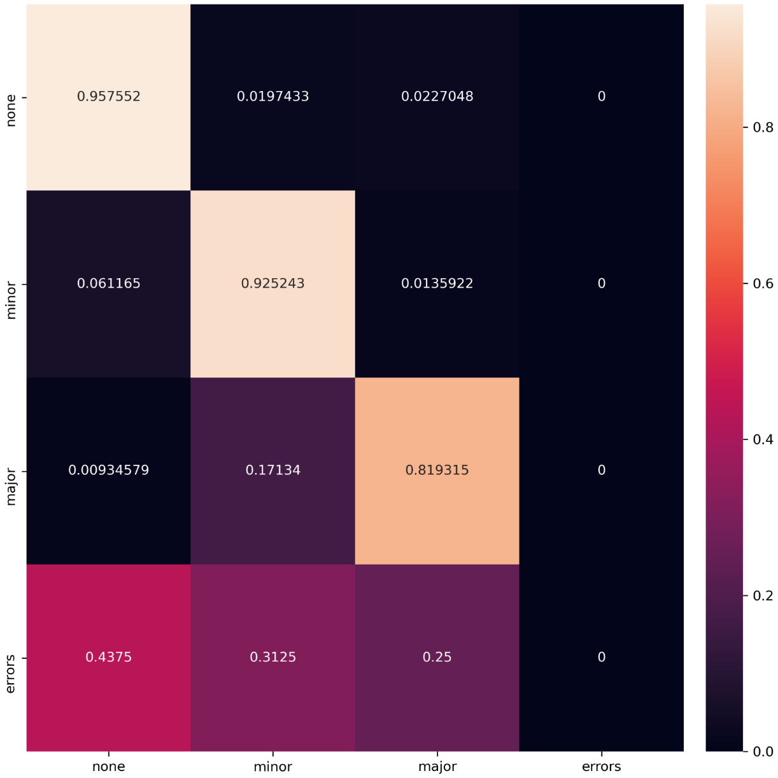

Figure 5. The normalized confusion matrix for the validation dataset. The intermediate ‘minor events’ class was sometimes confused for the end-member classes, but the end-members were almost never confused. The model did not classify any tiles as ‘errors’.

|  |  |
| --- | --- |
| A. (41%, 21%, 29%, 8%) | B. (90%, 4%, 1%, 5%) |
| C. (5%, 79%, 13%, 3%) | D. (18%, 24%, 45%, 13%) |

Figure 6. Tiles containing errors with confidences for each class: (none, minor, major, error). Both A) and B) were correctly classified as ‘No events’ despite the calibration pulse cutting across the tile. C) contains noise some light smudging which got passed the brightness check and was misclassified as ‘minor events’ when no microseisms are present. In D) the calibration pulse seems to have confused the network and it was misclassified as having ‘major events’. Note that only B) surpasses the 85% confidence threshold.

## 3.X Sample frequency

Figure 7 illustrates the variation in score ranges across the 50 evaluation images. For example, testing 10 samples tiles per film chip on ALQ_62_05_22_1626_LHZ five times produced scores of [1.2, 1.3, 1.0, 1, 1.2], a range of 0.3. This process was repeated for the other 49 evaluation chips to generate the 10-sample plot. The optimal sampling frequency was determined to be 100 samples per chip. This frequency balances minimizing the variability in score across tests and processing time. Using 200 samples greatly increased the processing time and did not meaningfully change the average spread of the scores.

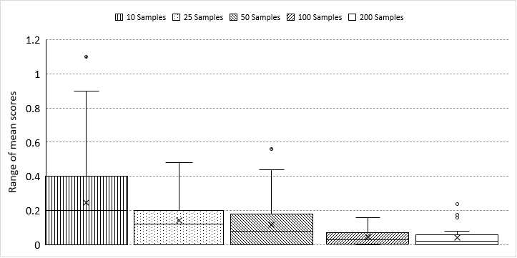

Figure 7. Box-and-whisker plots of the variability in mean scores across five test runs for each of the 50 evaluation film chips using five different sampling frequencies. Note the pronounced decrease in variability with increasing sample size. The small difference between 100 and 200 samples may indicate that the sampling method was reaching saturation in terms of finding high-confidence samples to take.

## 3.X Label generation

The label-generating logic produces useful labels. Differences between the human classifiers were typically at least as large than the difference between the model’s label and the consensus label; there was as large a difference between the manual classifications as between the model and the consensus. There was good agreement between the model and average human label: the model correctly predicted the consensus label 48% of the time. There was no systematic imbalance in the model’s predictions: the model predicted one class over the human label in 20% of the chips, and predicted one class lower in 22% of the chips. This indicates that the model was not biased in one direction over another. Only 10% of the chips were mislabeled by two classes: 8% overpredicting interest, and 2% underpredicting. This means the model is much more likely to produce false positive results than false negative results. Since the model is a first-pass meant to reduce the number of film chips for human review, false-positives are preferrable and this result is acceptable.

The label-generating logic was also very consistent across multiple test runs. Across the 50 tiles and five tests, only two labels changed, once from ‘interest’ to ‘high interest’ (LUB_62_02_15_1642_LHZ), and once from ‘no interest’ to ‘little interest’ (BEC_62_05_31_1240_SHE). This corresponds to an uncertainty of <1%, meaning that rerunning film chips will not produce different results, making the results repeatable.

The entire pipeline is efficient. In total, it took 4.96 seconds to process each of the 50 test chips. In total the 50 test chips took 248 seconds in a single thread. This number could have been greatly reduced by creating multiple processes on the 24-thread processor used in this study, in theory, this could have reduced the processing time by a factor of 24 down to ~10 seconds.

## 3.X Application to the WWSSN archive

# 4. Discussion

## 4.X Interpreting model classifications

Additional code was written to overlay the sample tile locations and classifications on image chips. These visualizations allow for some interpretation of the model’s sampling patterns and classification quirks (Figure 8). In the future, these visualizations could be generated as an optional overlay in a web interface to aid in the interpretation of the film chip archive.

|  |
| --- |
| *A)* |
| *B)* |
| *C)* |
| *D)* |

Figure 8. Four examples of chips with tile visualizations. Grey indicates ‘no events’, yellow indicates ‘minor events’, and red indicates ‘major events’. Edges of the film chips have been cropped for space. A) A chip with low-amplitude long-period background noise, correctly classified as ‘no interest’ (BEC_62_05_31_1240_LHZ). B) A chip where irregular short-period noise was mistakenly classified as ‘major events’. There is an event on the left side, one-third down, so this chip was correctly labelled as ‘highly interesting’, but the model did confuse the nature of the traces (ADE_62_05_22_0048_SHZ). C) A chip with a major event clearly identified by the row of red tiles. Note that due to the masking process, the seemingly erroneous data at the top before the calibration pulse was not considered. This chip was labeled as ‘interesting’ (COP_62_05_22_0000_LHZ). D) A chip with highly irregular data. The top of the chip contains extremely high-amplitude long-period data, which dies off throughout the course of the dat. The irregularity of the data caused the model to detect many ‘major events’ tiles at the top of the chip, along with a clear event that runs across the middle of the image. This chip was classified as ‘highly interesting’ (DAL_62_05_22_1425_LHE).

## 4.X Inconsistent gain

There were potential problems introduced by inconsistent gain settings used at different stations and times in the data (Figure 9). High gain settings make interpretation and classification of the film chips more difficult for both humans and SeisNet. The increased amplitude can both cause small events to appear much larger, and also hide detail in the traces, potentially confusing the network since the data are not perfectly comparable across stations. The film chips do contain metadata about the gain corrections, but this problem is likely intractable without fully digitizing each film chip’s traces, which at present is itself not feasible.

|  |  |
| --- | --- |
| *A)* | *B)* |
| *C)* | *D)* |

Figure 9. A comparison of gain settings in the archive. A) Has normal gain with minute markers clearly visible and flat straight lines (GEO_62_05_31_1006_LHZ). This film chip was classified as ‘little interest’. B) Has a hand-written annotation noting a new gain setting that proved to be too high: “Gain under observation (new setting)” (ARE_62_05_22_1340_SHN). This film chip was classified as ‘little interest’. C) Another crop from ARE_62_05_22_1340_SHN where the high gain setting actually caused an event’s trace to disappear. D) The same cropped area as C) with the model’s sample tiles and classifications superimposed. Yellow indicates ‘minor events’, demonstrating that the unusually high gain resulted in incorrect classifications and overall labelling.

## 4.X Future work

### 4.X.X Balancing training data

Reducing the class imbalance in the training data would likely improve the model’s results. As tested and implemented, no balance corrections were applied. Something as simple as oversampling the minority classes to match the frequency of the ‘no events’ class could be beneficial, but more advanced techniques such as SMOTE [35] could also be effective. That said, the robust performance of SeisNet as-is suggests that any improvements are likely to be marginal, and perhaps not cost-effective given the need to re-train, test, evaluate, and apply any improved model.

### 4.X.X Spatial autocorrelation

Given that the seismic records are essentially spatial records of temporal data, spatial analytical techniques could be applied to improve the classification and labelling process. One such technique would be to check the locations of ‘major events’ for spatial autocorrelation [36–40], since the seismic event itself will be temporally continuous and thus autocorrelated. Interesting tiles that are spatially autocorrelated could then be weighted more than outlier or isolated tiles that are more likely to be erroneous. Spatial autocorrelation is well-characterized in the literature, and rapid robust tests for it are easy to implement [40–42].

# 5. Conclusions

# 6. Acknowledgements

Do we need to put anything here?

# 7. Author contributions

**T.P. Nagle-McNaughton:** Conceptualization, Data curation, Formal Analysis, Investigation, Methodology, Validation, Visualization, Writing – original draft, Writing – review & editing.

**A.T. Ringler:** Conceptualization, Data curation, Funding acquisition, Project administration, Resources, Supervision, Validation, Writing – review & editing.

**R.E. Anthony:** Conceptualization, Data curation, Funding acquisition, Project administration, Resources, Supervision, Validation, Writing – review & editing.

**D.C. Wilson:** Validation, Writing – review & editing.

**J.T. Wilgus:** Validation, Writing – review & editing.

# 8. Funding

Do we need to put anything here?

# 9. Conflicts of interest

The authors declare no conflicts of interest.

# 10. Data access and availability

All of the film chips used to train the model are from the publicly available database at <http://ds.iris.edu/spud/filmchip>. A list of the film chips used is available at <https://github.com/TimNagle-McNaughton/USGS/scan_classification>. Additionally, the fully trained SeisNet model, the code used to create and train SeisNet, and the pipeline code are available in the same repository.

# References

1. Alejandro, A.C.B.; Hutt, C.R.; Ringler, A.T.; Moore, S. v.; Anthony, R.E.; Wilson, D.C. The Albuquerque Seismological Lab WWSSN Film Chip Preservation Project. *Seismological Research Letters* **2019**, *90*, 401–408, doi:10.1785/0220180275.

2. Rawat, W.; Wang, Z. Deep Convolutional Neural Networks for Image Classification: A Comprehensive Review. *Neural Computation* **2017**, *29*, doi:10.1162/NECO.

3. Voulodimos, A.; Doulamis, N.; Doulamis, A.; Protopapadakis, E. Deep Learning for Computer Vision: A Brief Review. *Computational Intelligence and Neuroscience* **2018**, *2018*, doi:10.1155/2018/7068349.

4. Khan, S.; Rahmani, H.; Shah, S.A.A.; Bennamoun, M. A Guide to Convolutional Neural Networks for Computer Vision. *Synthesis Lectures on Computer Vision* **2018**, *8*, 1–207, doi:10.2200/s00822ed1v01y201712cov015.

5. Razavian, A.; Azizpour, H.; Sullivan, J.; Carlsson, S. CNN Features Off-the-Shelf: An Astounding Baseline for Recognition. In Proceedings of the 2014 IEEE Conference on Computer Vision and Pattern Recognition; Columbus, OH, 2014; pp. 806–813.

6. Ghosh, M.M.A.; Maghari, A.Y. A Comparative Study on Handwriting Digit Recognition Using Neural Networks. *Proceedings - 2017 International Conference on Promising Electronic Technologies, ICPET 2017* **2017**, 77–81, doi:10.1109/ICPET.2017.20.

7. An, S.; Lee, M.; Park, S.; Yang, H.; So, J. An Ensemble of Simple Convolutional Neural Network Models for MNIST Digit Recognition. **2020**.

8. Alakwaa, W.; Nassef, M.; Badr, A. Lung Cancer Detection and Classification with 3D Convolutional Neural Network (3D-CNN). *International Journal of Biology and Biomedical Engineering* **2017**, *11*, 66–73, doi:10.14569/ijacsa.2017.080853.

9. Wang, Z.; Li, M.; Wang, H.; Jiang, H.; Yao, Y.; Zhang, H.; Xin, J. Breast Cancer Detection Using Extreme Learning Machine Based on Feature Fusion with CNN Deep Features. *IEEE Access* **2019**, *7*, 105146–105158, doi:10.1109/ACCESS.2019.2892795.

10. Gao, F.; Wu, T.; Li, J.; Zheng, B.; Ruan, L.; Shang, D.; Patel, B. SD-CNN: A Shallow-Deep CNN for Improved Breast Cancer Diagnosis. *Computerized Medical Imaging and Graphics* **2018**, *70*, 53–62, doi:10.1016/j.compmedimag.2018.09.004.

11. Fu, Y.; Lei, Y.; Wang, T.; Curran, W.J.; Liu, T.; Yang, X. Deep Learning in Medical Image Registration: A Review. *Physics in Medicine and Biology* **2020**, *65*, doi:10.1088/1361-6560/ab843e.

12. Muhammad, S.; Muhammad, A.; Adnan, M.; Muhammad, Q.; Majdi, A.; Khan, M.K. Medical Image Analysis Using Convolutional Neural Networks A Review. *Journal of Medical Systems* **2018**, 1–13.

13. Kattenborn, T.; Leitloff, J.; Schiefer, F.; Hinz, S. Review on Convolutional Neural Networks (CNN) in Vegetation Remote Sensing. *ISPRS Journal of Photogrammetry and Remote Sensing* **2021**, *173*, 24–49, doi:10.1016/j.isprsjprs.2020.12.010.

14. Zhu, X.X.; Tuia, D.; Mou, L.; Xia, G.S.; Zhang, L.; Xu, F.; Fraundorfer, F. Deep Learning in Remote Sensing: A Comprehensive Review and List of Resources. *IEEE Geoscience and Remote Sensing Magazine* **2017**, *5*, 8–36, doi:10.1109/MGRS.2017.2762307.

15. Ma, L.; Liu, Y.; Zhang, X.; Ye, Y.; Yin, G.; Johnson, B.A. Deep Learning in Remote Sensing Applications: A Meta-Analysis and Review. *ISPRS Journal of Photogrammetry and Remote Sensing* **2019**, *152*, 166–177, doi:10.1016/j.isprsjprs.2019.04.015.

16. Sewak, M.; Karim, M.R.; Pujari, P. *Practical Convolutional Neural Networks: Implement Advanced Deep Learning Models Using Python*; Packt Publishing Ltd, 2018; ISBN 1788394143.

17. Chollet, F. Keras: The Python Deep Learning Library. *Astrophysics Source Code Library* **2018**, ascl-1806.

18. Vasilev, I.; Slater, D.; Spacagna, G.; Roelants, P.; Zocca, V. *Python Deep Learning: Exploring Deep Learning Techniques and Neural Network Architectures with Pytorch, Keras, and TensorFlow*; Packt Publishing Ltd, 2019; ISBN 1789349702.

19. Gulli, A.; Pal, S. *Deep Learning with Keras*; Packt Publishing Ltd, 2017; ISBN 1787129039.

20. Nandy, A.; Biswas, M. *Reinforcement Learning: With Open AI, TensorFlow and Keras Using Python*; Apress, 2017; ISBN 1484232852.

21. Raschka, S.; Mirjalili, V. Python Machine Learning: Machine Learning and Deep Learning with Python. *Scikit-Learn, and TensorFlow. Second edition ed* **2017**.

22. Pang, B.; Nijkamp, E.; Wu, Y.N. Deep Learning with Tensorflow: A Review. *Journal of Educational and Behavioral Statistics* **2020**, *45*, 227–248.

23. Srinivasa-Desikan, B. *Natural Language Processing and Computational Linguistics: A Practical Guide to Text Analysis with Python, Gensim, SpaCy, and Keras*; Packt Publishing Ltd, 2018; ISBN 1788837037.

24. Hao, J.; Ho, T.K. Machine Learning Made Easy: A Review of Scikit-Learn Package in Python Programming Language. *Journal of Educational and Behavioral Statistics* **2019**, *44*, 348–361, doi:10.3102/1076998619832248.

25. Redmon, J.; Farhadi, A. YOLOv3: An Incremental Improvement. **2018**.

26. Alom, M.Z.; Taha, T.M.; Yakopcic, C.; Westberg, S.; Sidike, P.; Nasrin, M.S.; van Esesn, B.C.; Awwal, A.A.S.; Asari, V.K. The History Began from AlexNet: A Comprehensive Survey on Deep Learning Approaches. **2018**.

27. Iandola, F.N.; Han, S.; Moskewicz, M.W.; Ashraf, K.; Dally, W.J.; Keutzer, K. SqueezeNet: AlexNet-Level Accuracy with 50x Fewer Parameters and <0.5MB Model Size. **2016**, 1–13.

28. Li, Y.; Ren, F. Light-Weight RetinaNet for Object Detection. **2019**.

29. Shijie, J.; Ping, W.; Peiyi, J.; Siping, H. Research on Data Augmentation for Image Classification Based on Convolution Neural Networks. *Proceedings - 2017 Chinese Automation Congress, CAC 2017* **2017**, *2017-Janua*, 4165–4170, doi:10.1109/CAC.2017.8243510.

30. Perez, L.; Wang, J. The Effectiveness of Data Augmentation in Image Classification Using Deep Learning. **2017**.

31. Hussain, Z.; Gimenez, F.; Yi, D.; Rubin, D. Differential Data Augmentation Techniques for Medical Imaging Classification Tasks. *AMIA ... Annual Symposium proceedings. AMIA Symposium* **2017**, *2017*, 979–984.

32. Kingma, D.P.; Ba, J.L. Adam: A Method for Stochastic Optimization. *3rd International Conference on Learning Representations, ICLR 2015 - Conference Track Proceedings* **2015**, 1–15.

33. Hinton, G.E.; Srivastava, N.; Krizhevsky, A.; Sutskever, I.; Salakhutdinov, R.R. Improving Neural Networks by Preventing Co-Adaptation of Feature Detectors. **2012**, 1–18.

34. Srivastava, N.; Hinton, G.; Krizhevsky, A.; Sutskever, I.; Salakhutdinov, R. Dropout: A Simple Way to Prevent Neural Networks from Overfitting. *The journal of machine learning research* **2014**, *15*, 1929–1958.

35. Chawla, N. v; Bowyer, K.W.; Hall, L.O.; Kegelmeyer, W.P. SMOTE: Synthetic Minority over-Sampling Technique. *Journal of artificial intelligence research* **2002**, *16*, 321–357.

36. Legendre, P. Spatial Autocorrelation: Trouble or New Paradigm? *Ecology* **1993**, *74*, 1659–1673, doi:10.2307/1939924.

37. Getis, A. A History of the Concept of Spatial Autocorrelation: A Geographer’s Perspective. *Geographical Analysis* **2008**, *40*, 297–309.

38. Ord, J.K.; Getis, A. Local Spatial Autocorrelation Statistics: Distributional Issues and an Application. *Geographical Analysis* **1995**, *27*, 286–306, doi:10.1111/j.1538-4632.1995.tb00912.x.

39. Brandsma, A.S.; Ketellapper, R.H. Further evidence on alternative procedures for testing of spatial autocorrelation among regression disturbances. In *Exploratory and explanatory statistical analysis of spatial data*; Springer, 1979; pp. 113–136.

40. Bartels, C.P.A.; Hordijk, L. On the Power of the Generalized Moran Contiguity Coefficient in Testing for Spatial Autocorrelation among Regression Disturbances. *Regional Science and Urban Economics* **1977**, *7*, 83–101, doi:10.1016/0166-0462(77)90019-9.

41. Ord, J.K.; Getis, A. Local Spatial Autocorrelation Statistics: Distributional Issues and an Application. *Geographical Analysis* **1995**, *27*, 286–306, doi:10.1111/j.1538-4632.1995.tb00912.x.

42. Getis, A.; Ord, J.K. The Analysis of Spatial Association by Use of Distance Statistics. *Advances in Spatial Science* **2010**, *61*, 127–145, doi:10.1007/978-3-642-01976-0_10.